**2.Spring REST Handson**

**Hello World RESTful Web Service**

**1.HelloController.java**

package com.cognizant.spring_learn.controller;

import org.slf4j.Logger;

import org.slf4j.LoggerFactory;

import org.springframework.web.bind.annotation.GetMapping;

import org.springframework.web.bind.annotation.RestController;

*@RestController*

public class HelloController {

private static final Logger *LOGGER* = LoggerFactory.*getLogger*(HelloController.class);

*@GetMapping*("/hello")

public String sayHello() {

*LOGGER*.info("START");

String message = "Hello World!!";

*LOGGER*.info("END");

return message;

}}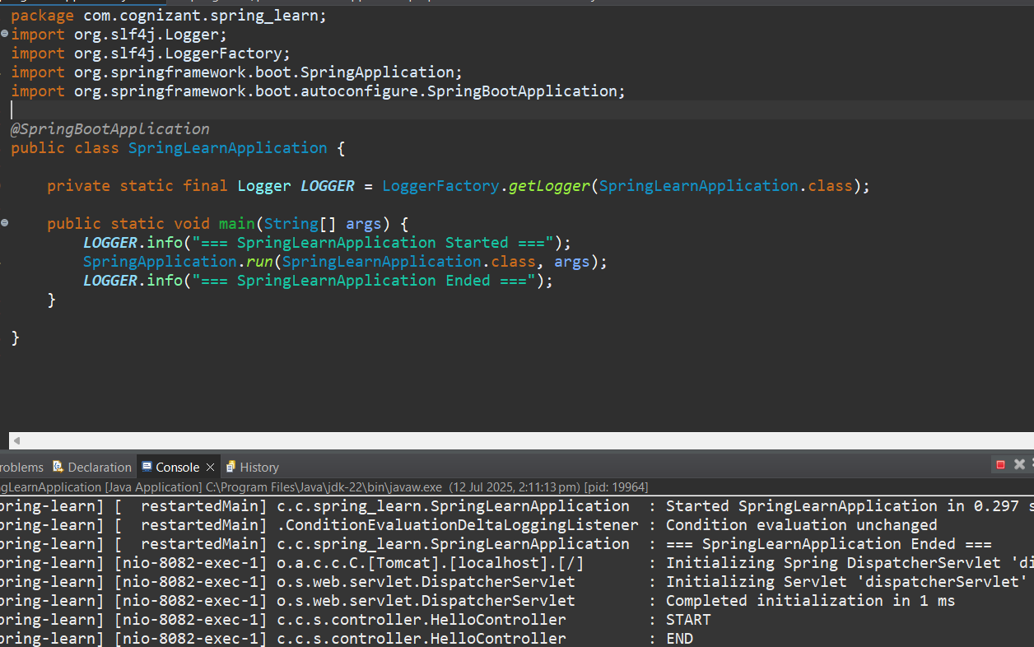

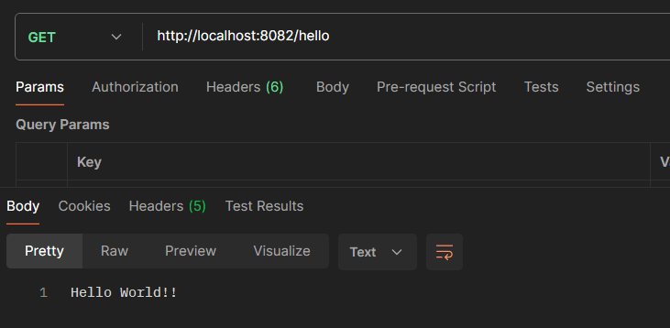

**REST - Country Web Service**

**1.Country.java**

package com.cognizant.spring_learn;

import org.slf4j.Logger;

import org.slf4j.LoggerFactory;

public class Country {

private static final Logger ***LOGGER*** = LoggerFactory.*getLogger*(Country.class);

private String code;

private String name;

public Country() {

***LOGGER***.debug("Inside Country Constructor");

}

public String getCode() {

***LOGGER***.debug("Getting country code: {}", code);

return code;

}

public void setCode(String code) {

***LOGGER***.debug("Setting country code: {}", code);

this.code = code;

}

public String getName() {

***LOGGER***.debug("Getting country name: {}", name);

return name;

}

public void setName(String name) {

***LOGGER***.debug("Setting country name: {}", name);

this.name = name;

}

*@Override*

public String toString() {

return "Country [code=" + code + ", name=" + name + "]";

}

}

**2.CountryController.java**

package com.cognizant.spring_learn.controller;

import com.cognizant.spring_learn.Country;

import org.slf4j.Logger;

import org.slf4j.LoggerFactory;

import org.springframework.context.ApplicationContext;

import org.springframework.context.support.ClassPathXmlApplicationContext;

import org.springframework.web.bind.annotation.RequestMapping;

import org.springframework.web.bind.annotation.RestController;

*@RestController*

public class CountryController {

private static final Logger ***LOGGER*** = LoggerFactory.*getLogger*(CountryController.class);

*@RequestMapping*("/country")

public Country getCountryIndia() {

***LOGGER***.info("START - getCountryIndia()");

ApplicationContext context = new ClassPathXmlApplicationContext("country.xml");

Country country = context.getBean("country", Country.class);

***LOGGER***.info("END - getCountryIndia()");

return country;

}

}

**3.SpringLearnApplication.java**

package com.cognizant.spring_learn;

import org.slf4j.Logger;

import org.slf4j.LoggerFactory;

import org.springframework.boot.SpringApplication;

import org.springframework.boot.autoconfigure.SpringBootApplication;

*@SpringBootApplication*

public class SpringLearnApplication {

private static final Logger ***LOGGER*** = LoggerFactory.*getLogger*(SpringLearnApplication.class);

public static void main(String[] args) {

***LOGGER***.info("=== SpringLearnApplication Started ===");

SpringApplication.*run*(SpringLearnApplication.class, args);

***LOGGER***.info("=== SpringLearnApplication Ended ===");

}

}

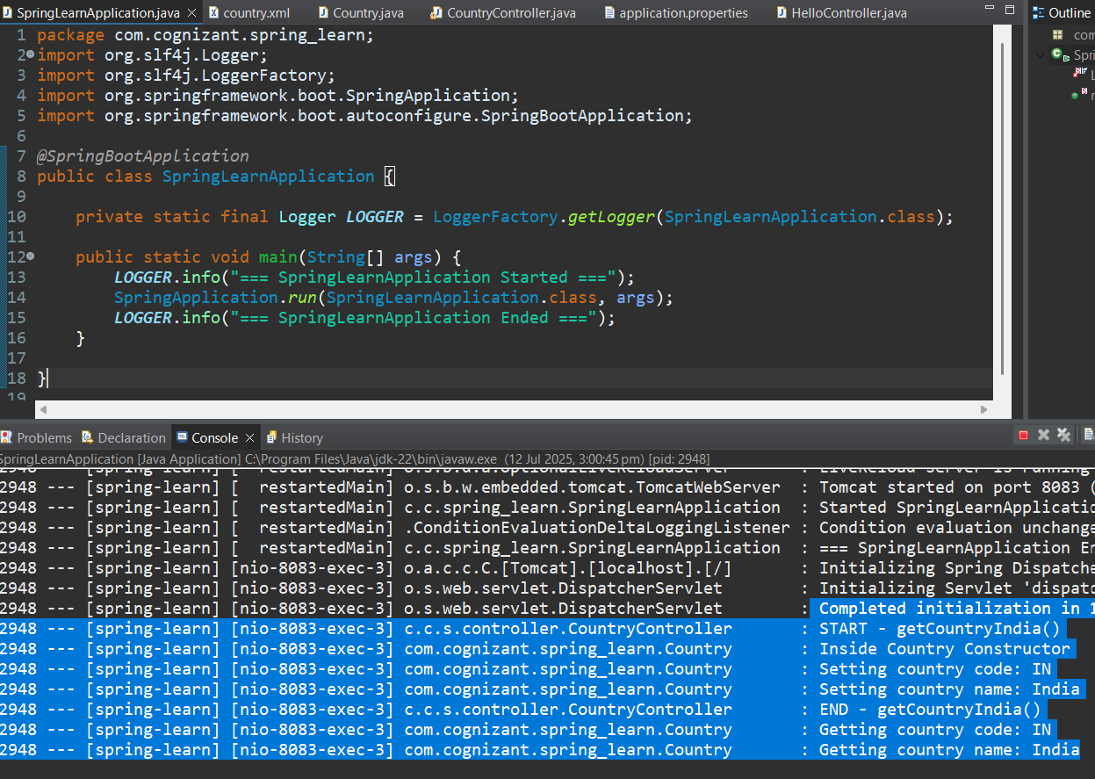

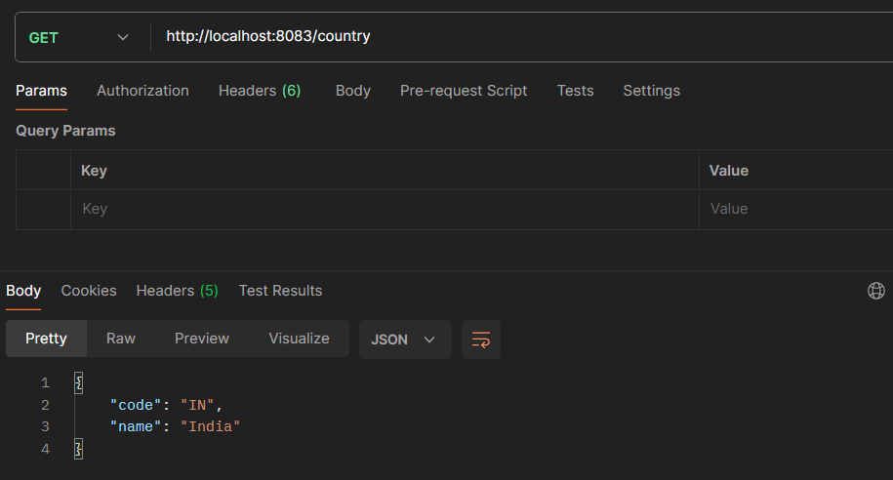

**REST - Get all countries**

**1.SpringLearnApplication.java**

package com.cognizant.spring_learn;

import org.slf4j.Logger;

import org.slf4j.LoggerFactory;

import org.springframework.boot.SpringApplication;

import org.springframework.boot.autoconfigure.SpringBootApplication;

*@SpringBootApplication*

public class SpringLearnApplication {

private static final Logger ***LOGGER*** = LoggerFactory.*getLogger*(SpringLearnApplication.class);

public static void main(String[] args) {

***LOGGER***.info("=== SpringLearnApplication Started ===");

SpringApplication.*run*(SpringLearnApplication.class, args);

***LOGGER***.info("=== SpringLearnApplication Ended ===");

}

}

**Country.xml**

<?xml version="1.0" encoding="UTF-8"?>

<beans xmlns="http://www.springframework.org/schema/beans"

xmlns:xsi="http://www.w3.org/2001/XMLSchema-instance"

xsi:schemaLocation="

http://www.springframework.org/schema/beans

http://www.springframework.org/schema/beans/spring-beans.xsd">

<bean id="country" class="com.cognizant.spring_learn.Country">

<property name="code" value="IN" />

<property name="name" value="India" />

</bean>

<bean id="countryList" class="java.util.ArrayList">

<constructor-arg>

<list>

<bean class="com.cognizant.spring_learn.Country">

<property name="code" value="IN" />

<property name="name" value="India" />

</bean>

<bean class="com.cognizant.spring_learn.Country">

<property name="code" value="US" />

<property name="name" value="United States" />

</bean>

<bean class="com.cognizant.spring_learn.Country">

<property name="code" value="JP" />

<property name="name" value="Japan" />

</bean>

<bean class="com.cognizant.spring_learn.Country">

<property name="code" value="DE" />

<property name="name" value="Germany" />

</bean>

</list>

</constructor-arg>

</bean>

</beans>

**CountryController.java**

package com.cognizant.spring_learn.controller;

import com.cognizant.spring_learn.Country;

import org.slf4j.Logger;

import org.slf4j.LoggerFactory;

import org.springframework.context.ApplicationContext;

import org.springframework.context.support.ClassPathXmlApplicationContext;

import org.springframework.web.bind.annotation.GetMapping;

import org.springframework.web.bind.annotation.RestController;

import java.util.List;

*@RestController*

public class CountryController {

private static final Logger ***LOGGER*** = LoggerFactory.*getLogger*(CountryController.class);

*@GetMapping*("/countries")

public List<Country> getAllCountries() {

***LOGGER***.info("START - getAllCountries()");

ApplicationContext context = new ClassPathXmlApplicationContext("country.xml");

List<Country> countryList = (List<Country>) context.getBean("countryList");

***LOGGER***.info("END - getAllCountries()");

return countryList;

}

}

**Country.java**

package com.cognizant.spring_learn.model;

import org.slf4j.Logger;

import org.slf4j.LoggerFactory;

public class Country {

private static final Logger LOGGER = LoggerFactory.getLogger(Country.class);

private String code;

private String name;

public Country() {

LOGGER.debug("Inside Country Constructor");

}

public String getCode() {

LOGGER.debug("Getting country code: {}", code);

return code;

}

public void setCode(String code) {

LOGGER.debug("Setting country code: {}", code);

this.code = code;

}

public String getName() {

LOGGER.debug("Getting country name: {}", name);

return name;

}

public void setName(String name) {

LOGGER.debug("Setting country name: {}", name);

this.name = name;

}

@Override

public String toString() {

return "Country [code=" + code + ", name=" + name + "]";

}

}

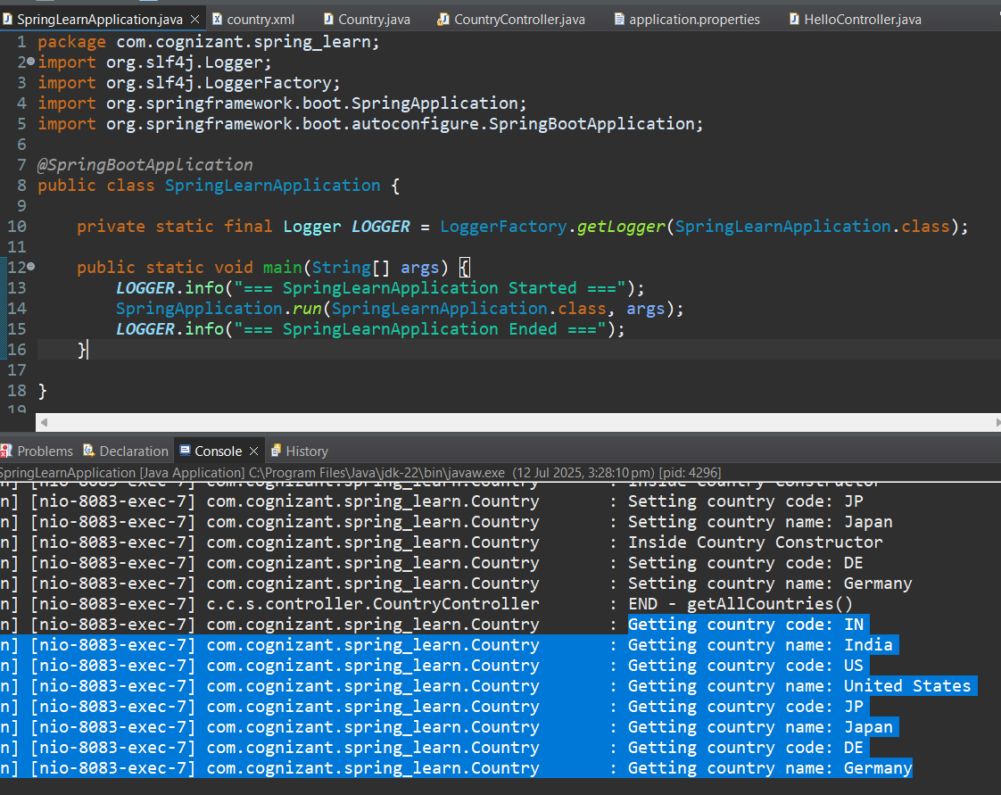

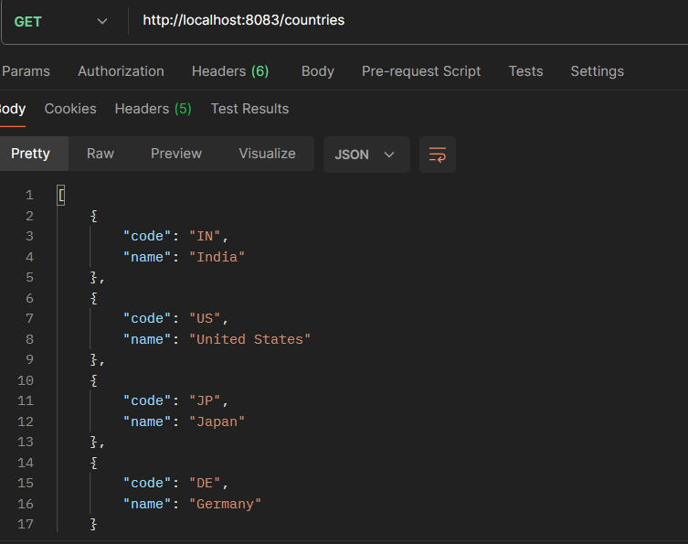

**REST - Get country based on country code**

**country.xml**

<beans xmlns="http://www.springframework.org/schema/beans"

xmlns:xsi="http://www.w3.org/2001/XMLSchema-instance"

xsi:schemaLocation="http://www.springframework.org/schema/beans

http://www.springframework.org/schema/beans/spring-beans.xsd">

<bean id="countryList" class="java.util.ArrayList">

<constructor-arg>

<list>

<bean class="com.cognizant.spring_learn.Country">

<property name="code" value="IN"/>

<property name="name" value="India"/>

</bean>

<bean class="com.cognizant.spring_learn.Country">

<property name="code" value="US"/>

<property name="name" value="United States"/>

</bean>

<bean class="com.cognizant.spring_learn.Country">

<property name="code" value="JP"/>

<property name="name" value="Japan"/>

</bean>

<bean class="com.cognizant.spring_learn.Country">

<property name="code" value="DE"/>

<property name="name" value="Germany"/>

</bean>

</list>

</constructor-arg>

</bean>

</beans>

**1.Country.java**

package com.cognizant.spring_learn;

import org.slf4j.Logger;

import org.slf4j.LoggerFactory;

public class Country {

private static final Logger ***LOGGER*** = LoggerFactory.*getLogger*(Country.class);

private String code;

private String name;

public Country() {

***LOGGER***.debug("Inside Country Constructor");

}

public String getCode() {

***LOGGER***.debug("Getting country code: {}", code);

return code;

}

public void setCode(String code) {

***LOGGER***.debug("Setting country code: {}", code);

this.code = code;

}

public String getName() {

***LOGGER***.debug("Getting country name: {}", name);

return name;

}

public void setName(String name) {

***LOGGER***.debug("Setting country name: {}", name);

this.name = name; }

*@Override*

public String toString() {

return "Country [code=" + code + ", name=" + name + "]";

}}

**CountryService.java**

package com.cognizant.spring_learn.service;

import com.cognizant.spring_learn.Country;

import org.slf4j.Logger;

import org.slf4j.LoggerFactory;

import org.springframework.context.ApplicationContext;

import org.springframework.context.support.ClassPathXmlApplicationContext;

import org.springframework.stereotype.Service;

import java.util.List;

*@Service*

public class CountryService {

private static final Logger ***LOGGER*** = LoggerFactory.*getLogger*(CountryService.class);

public Country getCountry(String code) {

***LOGGER***.info("START - getCountry({})", code);

ApplicationContext context = new ClassPathXmlApplicationContext("country.xml");

List<Country> countryList = (List<Country>) context.getBean("countryList");

return countryList.stream()

.filter(c -> c.getCode().equalsIgnoreCase(code))

.findFirst()

.orElse(null); // or throw custom exception

}

}

**CountryController.java**

package com.cognizant.spring_learn.controller;

import com.cognizant.spring_learn.Country;

import com.cognizant.spring_learn.service.CountryService;

import org.slf4j.Logger;

import org.slf4j.LoggerFactory;

import org.springframework.beans.factory.annotation.Autowired;

import org.springframework.web.bind.annotation.*;

*@RestController*

public class CountryController {

private static final Logger ***LOGGER*** = LoggerFactory.*getLogger*(CountryController.class);

*@Autowired*

private CountryService countryService;

*@GetMapping*("/countries/{code}")

public Country getCountry(*@PathVariable* String code) {

***LOGGER***.info("START - getCountry({})", code);

Country country = countryService.getCountry(code);

***LOGGER***.info("END - getCountry()");

return country;

}}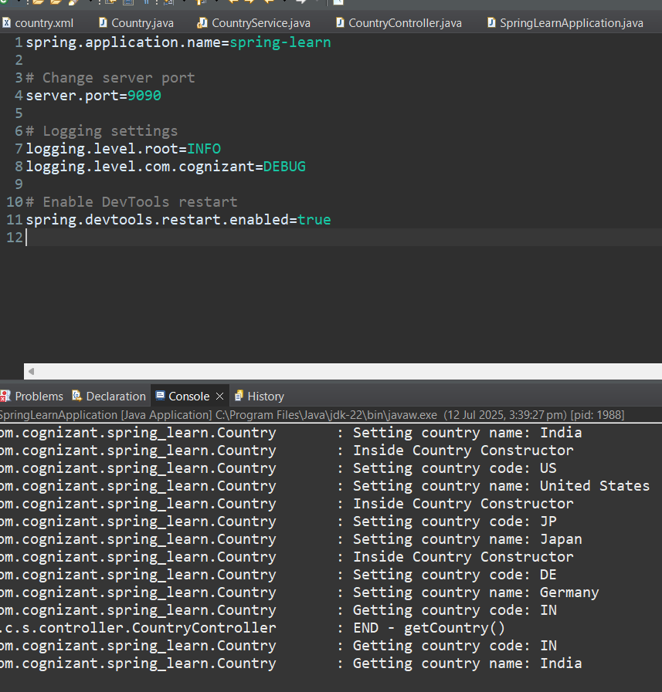

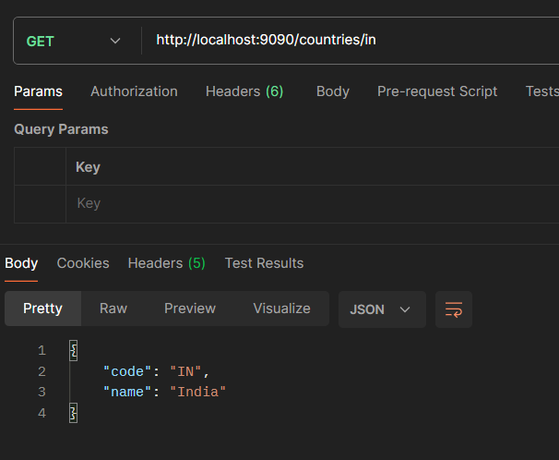

**REST - Get country exceptional scenario**

**1.Country.java**

package com.cognizant.spring_learn;

import org.slf4j.Logger;

import org.slf4j.LoggerFactory;

public class Country {

private static final Logger ***LOGGER*** = LoggerFactory.*getLogger*(Country.class);

private String code;

private String name;

public Country() {

***LOGGER***.debug("Inside Country Constructor");

}

public String getCode() {

***LOGGER***.debug("Getting country code: {}", code);

return code;

}

public void setCode(String code) {

***LOGGER***.debug("Setting country code: {}", code);

this.code = code;

}

public String getName() {

***LOGGER***.debug("Getting country name: {}", name);

return name;

}

public void setName(String name) {

***LOGGER***.debug("Setting country name: {}", name);

this.name = name;

}

*@Override*

public String toString() {

return "Country [code=" + code + ", name=" + name + "]";

}

}

**CountryService.java**

package com.cognizant.spring_learn.service;

import com.cognizant.spring_learn.Country;

import com.cognizant.spring_learn.service.exception.CountryNotFoundException;

import org.springframework.context.ApplicationContext;

import org.springframework.context.support.ClassPathXmlApplicationContext;

import org.springframework.stereotype.Service;

import java.util.List;

*@Service*

public class CountryService {

public Country getCountry(String code) throws CountryNotFoundException {

ApplicationContext context = new ClassPathXmlApplicationContext("country.xml");

List<Country> countries = (List<Country>) context.getBean("countryList");

return countries.stream()

.filter(c -> c.getCode().equalsIgnoreCase(code))

.findFirst()

.orElseThrow(() -> new CountryNotFoundException("Country with code " + code + " not found"));

}

}

**CountryController.java**

package com.cognizant.spring_learn.controller;

import com.cognizant.spring_learn.model.Country;

import com.cognizant.spring_learn.service.CountryService;

import com.cognizant.spring_learn.service.exception.CountryNotFoundException;

import org.springframework.beans.factory.annotation.Autowired;

import org.springframework.web.bind.annotation.*;

@RestController

public class CountryController {

@Autowired

private CountryService countryService;

@GetMapping("/countries/{code}")

public Country getCountry(@PathVariable String code) throws CountryNotFoundException {

return countryService.getCountry(code);

}

}

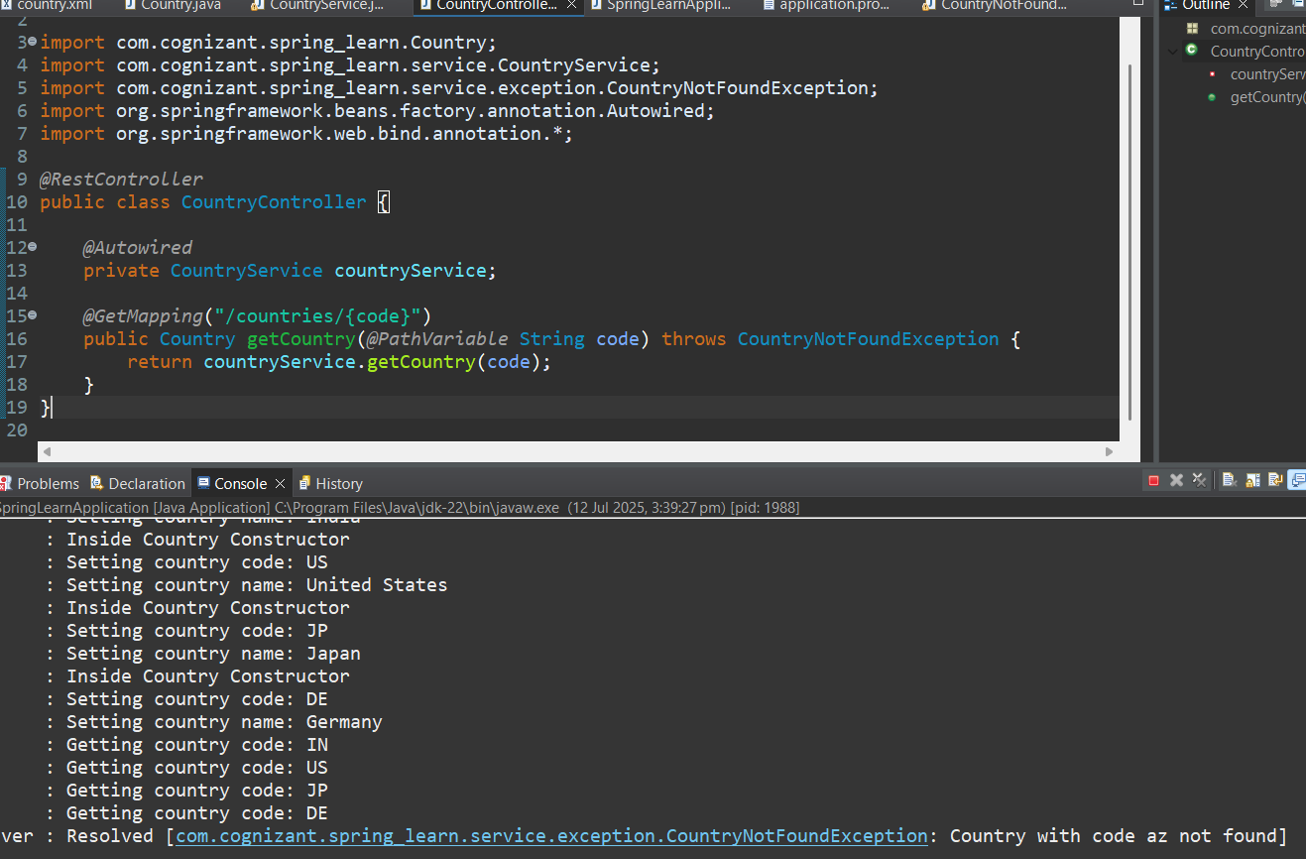

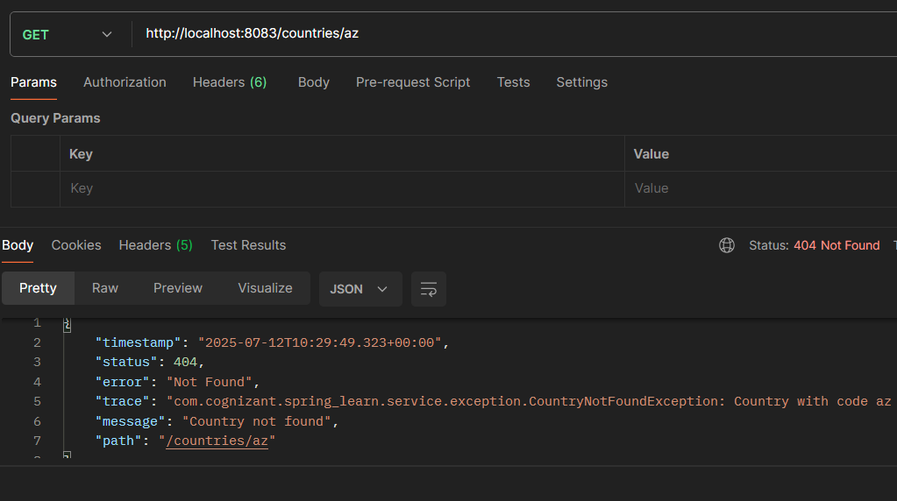

MockMVC - Test get country service

1.SpringLearnApplicationTests.java

package com.cognizant.spring_learn;

import static org.junit.jupiter.api.Assertions.assertNotNull;

import static org.springframework.test.web.servlet.request.MockMvcRequestBuilders.get;

import static org.springframework.test.web.servlet.result.MockMvcResultMatchers.status;

import static org.springframework.test.web.servlet.result.MockMvcResultMatchers.jsonPath;

import org.junit.jupiter.api.Test;

import org.springframework.beans.factory.annotation.Autowired;

import org.springframework.boot.test.autoconfigure.web.servlet.AutoConfigureMockMvc;

import org.springframework.boot.test.context.SpringBootTest;

import org.springframework.test.web.servlet.MockMvc;

import org.springframework.test.web.servlet.ResultActions;

import com.cognizant.spring_learn.controller.CountryController;

@SpringBootTest

@AutoConfigureMockMvc

public class SpringLearnApplicationTests {

@Autowired

private CountryController countryController;

@Autowired

private MockMvc mvc;

@Test

public void contextLoads() {

// Verifies the controller is successfully loaded

assertNotNull(countryController);

}

@Test

public void testGetCountry() throws Exception {

// Perform GET request to /country

ResultActions actions = mvc.perform(get("/country"));

// Expect HTTP 200 OK status

actions.andExpect(status().isOk());

// Check if the response contains "code" = "IN"

actions.andExpect(jsonPath("$.code").exists());

actions.andExpect(jsonPath("$.code").value("IN"));

// Check if the response contains "name" = "India"

actions.andExpect(jsonPath("$.name").exists());

actions.andExpect(jsonPath("$.name").value("India"));

}

}

